Term Project: *ChatApp*

Test Plan Document

Table of Contents

1 Introduction 4

1.1 Purpose and Scope 4

1.2 Target Audience 4

1.3 Terms and Definitions 4

2 Test Plan Description 5

2.1 Scope of Testing 5

2.2 Testing Schedule 5

2.3 Release Criteria 5

3 Unit Testing 6

3.1 Register 6

3.1.1 Input Data 6

3.1.1.1 No ID 6

3.1.1.2 ID & No Passwords 6

3.1.1.3 ID & Passwords Don't Match 6

3.1.1.4 ID & Passwords Match 6

3.1.2 ID Already Exists 6

3.1.3 ID Is Available 7

3.1.3.1 ID Is Alphabetically First 7

3.1.3.2 ID Is Alphabetically Last 7

3.1.3.3 ID Becomes New Root In Chatter Tree 7

3.1.3.4 ID Within Range 8

3.2 Log In 8

3.2.1 Input Data 8

3.2.1.1 No ID 8

3.2.1.2 ID & No Password 8

3.2.1.3 ID & Password 8

3.2.2 ID Doesn't Exist 8

3.2.3 ID Exists 8

3.2.3.1 ID Exists, Password Doesn't Match 9

3.2.3.2 ID Exists, Password Matches 9

3.3 Chat 10

3.3.1 Public Chat 10

3.3.1.1 Open Public Chat 11

3.3.1.2 Messages 11

3.3.1.2.1 Message Sent 11

3.3.1.2.2 Empty Message Sent 11

3.3.1.3 Open Private Chat 11

3.3.2 Private Chat 12

3.3.2.1 Message Sent 12

3.3.2.2 Empty Message Sent 13

3.4 Access Chat Records 13

3.4.1 No Records Exist 13

3.4.2 Records Exist 13

3.5 Log Out 14

4 Integration Testing 15

4.1 Register 15

4.1.1 Input Data 15

4.1.1.1 No ID 15

4.1.1.2 ID & No Passwords 15

4.1.1.3 ID & Passwords Don't Match 15

4.1.1.4 ID & Passwords Match 15

4.1.2 ID Already Exists 16

4.1.3 ID Is Available 16

4.1.3.1 ID Is Alphabetically First 16

4.1.3.2 ID Is Alphabetically Last 16

4.1.3.3 ID Becomes New Root In Chatter Tree 16

4.1.3.4 ID Within Range 16

4.2 Log In 16

4.2.1 Input Data 16

4.2.1.1 No ID 17

4.2.1.2 ID & No Password 17

4.2.1.3 ID & Password 17

4.2.2 ID Doesn't Exist 17

4.2.3 ID Exists 17

4.2.3.1 ID Exists, Password Doesn't Match 17

4.2.3.2 ID Exists, Password Matches 17

4.3 Chat 17

4.3.1 Public Chat 18

4.3.1.1 Open Public Chat 18

4.3.1.2 Messages 18

4.3.1.2.1 Message Sent 18

4.3.1.2.2 Empty Message Sent 18

4.3.1.3 Open Private Chat 18

4.3.2 Private Chat 18

4.3.2.1 Message Sent 19

4.3.2.2 Empty Message Sent 19

4.4 Access Chat Records 19

4.4.1 No Records Exist 19

4.4.2 Records Exist 19

4.5 Log Out 19

# Introduction

This section describes the purpose of this document, whom the document is intended for, and definitions needed for this document.

## Purpose and Scope

The purpose of this document is to describe the testing that will be done on the ChatApp prior to deployment.

## Target Audience

The target audience for this document are Professor Xie, T.A. Bin Lin, and the developer, Cole Phares

## Terms and Definitions

|  |  |
| --- | --- |
| Chat Environment | an area where messages received are displayed for other chatters. |
| Records Environment | an area where previous posts are printed for chatters to view. |
| Chatter 1 | a user of the application. |
| Chatter 2 | one other user. |
| Chatter N | one or more other users. |
| ID | user name chatter wants to be identified as. |
| Registry | database of accounts |
| Module | use case |
| Text Area | a container in GUI that displays messages |
| Text Field | a container where Chatters enter text in chat environments |

# Test Plan Description

This section describes the scope of testing required for this application, an outline for when testing should be performed, and functional requirements that must be met before deployment.

## Scope of Testing

Testing will be done on all use cases that are mentioned in the Requirements Document: Register, Log In, Public Chat, Private Chat, Access Chat Records, and Log Out. Testing will be performed on incorrect or incomplete data from the chatter (Register and Log In) as well as what happens when requests are made by the chatter without fulfilling the requirements (i.e. hitting send button in chat when no text has been entered). Testing will not be performed on the load the ChatApp can handle due to the time and manpower needed for testing.

## Testing Schedule

Testing will occur on each module upon completion of module and prior to integration.

Testing Schedule:

1. Finish writing classes & GUI: 5/30/17
2. Testing of classes: 5/31/17
3. Integrate: 6/1/17
4. Integrate testing: 6/5/17

## Release Criteria

All modules must be functional before deployment as a fault in any module will disable its functionality.

# Unit Testing

The purpose of this section is to describe testing required on each module of ChatApp.

## Register

This module will create an account for a new Chatter. It will ask Chatter to enter an ID and enter a password twice for comparison. If both passwords match, this module will search the database of existing Chatters to determine if the ID entered is available. If ID is available, an account will be created and stored in database, Chatter will be logged in, and Chatter will be allowed access to application. Project has passed test case when new Chatter is listed in logged in Chatter list.

### Input Data

Testing for this module will check what happens when incomplete or incorrect data is entered in the ID and Password text fields.

### No ID

If no ID is entered, then Register will inform Chatter 1 that an ID is required to register.

### ID & No Passwords

If ID is entered but no Passwords are entered, Register will inform Chatter 1 that Passwords are required to register.

### ID & Passwords Don’t Match

If ID is entered and Passwords don’t match, Register will inform Chatter 1 that their Passwords don’t match.

### ID & Passwords Match

If ID is entered and Passwords match, Register will search database of Chatters to determine if the ID entered is available.

### ID Already Exists

If the ID entered by Chatter already exists, Register will inform Chatter to choose a different ID.

### ID Is Available

If ID entered is available, testing will be done on the location of new Chatter in the Chatter database.

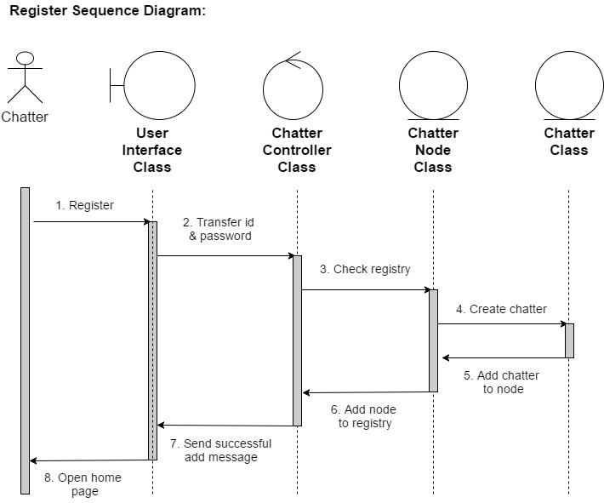

### ID Is Alphabetically First

Account will be entered in the farthest node on the left of the tree Chatter database.

### ID Is Alphabetically Last

Account will be entered in the farthest node on the right of the tree Chatter database.

### ID Becomes New Root in Chatter Tree

Account will become the new root of the tree Chatter database.

### ID Within Range

Account will be entered within the accepted range away from the boundary cases.

## Log In

This module will ask Chatter 1 to enter in their ID and Password. If input is acceptable, it will search Chatter database to find ID. If ID is found, the module will compare the entered Password with the Password on file else it will alert Chatter 1 that the ID does not exist. If the Password matches, Chatter 1 will be marked as logged in else it will alert Chatter 1 that the Password does not match the one on file. If ID and Password match, Chatter 1 will be granted access to application. Project has passed test case when new Chatter 1 is listed in logged in Chatter list.

### Input Data

Testing for this module will check what happens when incomplete or incorrect data is entered in the ID and Password text fields.

### No ID

If no ID is entered, then module will inform Chatter 1 that an ID is required to log in.

### ID & No Password

If ID is entered but no Password are entered, the module will inform Chatter 1 that a Password is required to log in.

### ID & Password

If ID is and Password are entered, the module will search database of Chatters to determine if the ID entered exists.

### ID Doesn’t Exist

If ID does not exist, alert Chatter 1 that the ID entered does not exist.

### ID Exists

If ID entered by Chatter 1 exists in the database, check to verify that the Password entered matches on file Password.

### ID Exists, Password Doesn’t Match

If the ID entered exists but the Password does not match what is on file, alert Chatter 1 that the Password entered does not match on file Password.

### ID Exists, Password Matches

If the ID entered exists and the Password matches, grant access to application to Chatter 1.

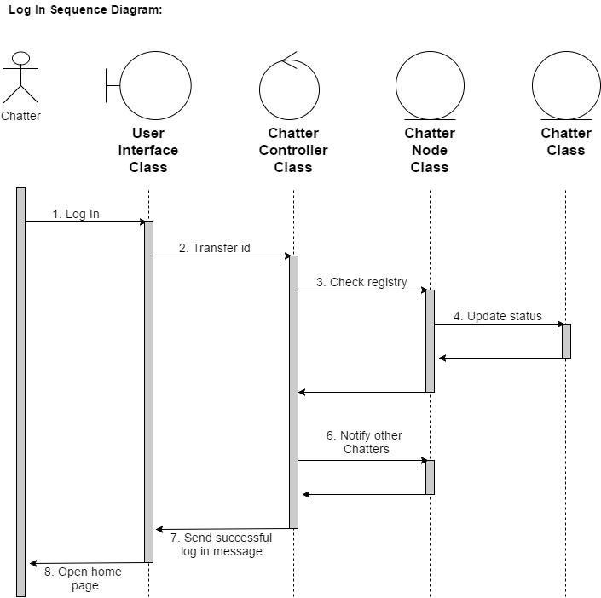

## Chat

There are two chat environments in this application. The Public Chat module allows Chatters to send messages to and receive messages from other logged in Chatters. Public Chat also shows the list of logged in Chatters. Chatters can double click on another Chatter on this list to open a Private Chat with them.

## Public Chat

Testing for this module will include tests for opening Public Chat. Testing for Sub-cases will include tests on sending and storing messages as well as opening a Private Chat with another Chatter. Project will pass test case when Public Chat environment opens.

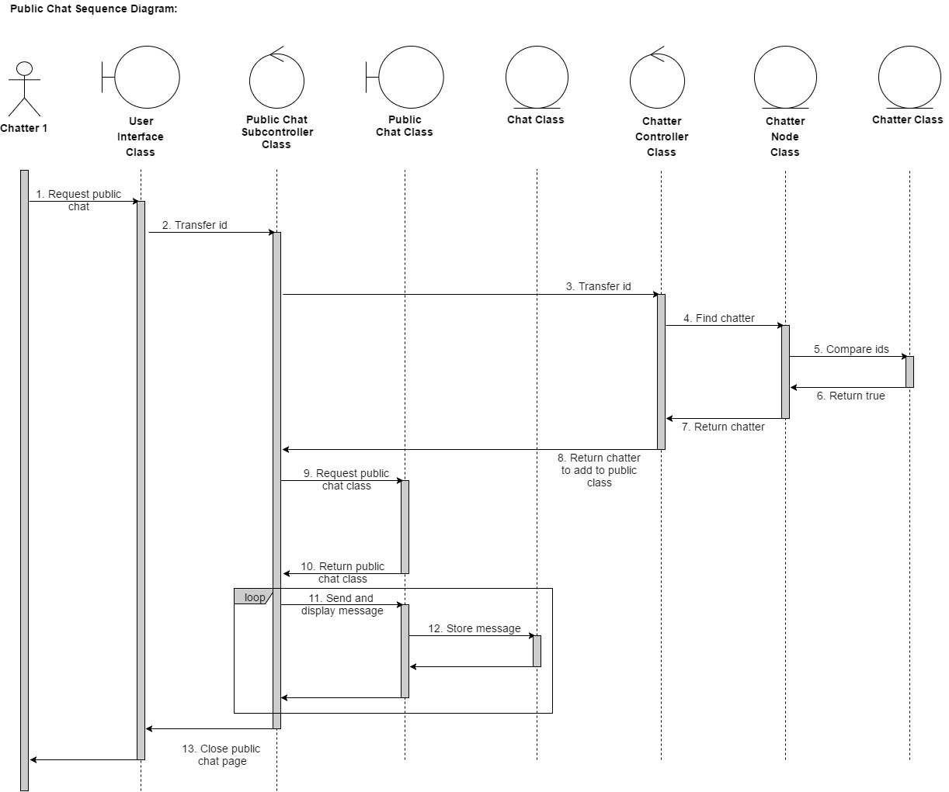

## Open Public Chat

If Chatter 1 clicks on “Public Chat” button, this module will open the public chat environment.

## Messages

Testing messages will include tests for sending a message of length greater than 0 and sending a message of length equal to 0.

## Message Sent

If text field is not empty when Chatter 1 presses “Send” button, this module will display message on the text area and store the message in the Public Chat records.

## Empty Message Sent

If text field is empty when Chatter 1 presses “Send” button, this module will do nothing.

## Open Private Chat

If Chatter 1 double-clicks on a Chatter 2 in the list, this module will open a Private Chat environment.

## Private Chat

Testing for this module will include test for sending and storing messages. Project will pass test case when messages are sent and stored in records.

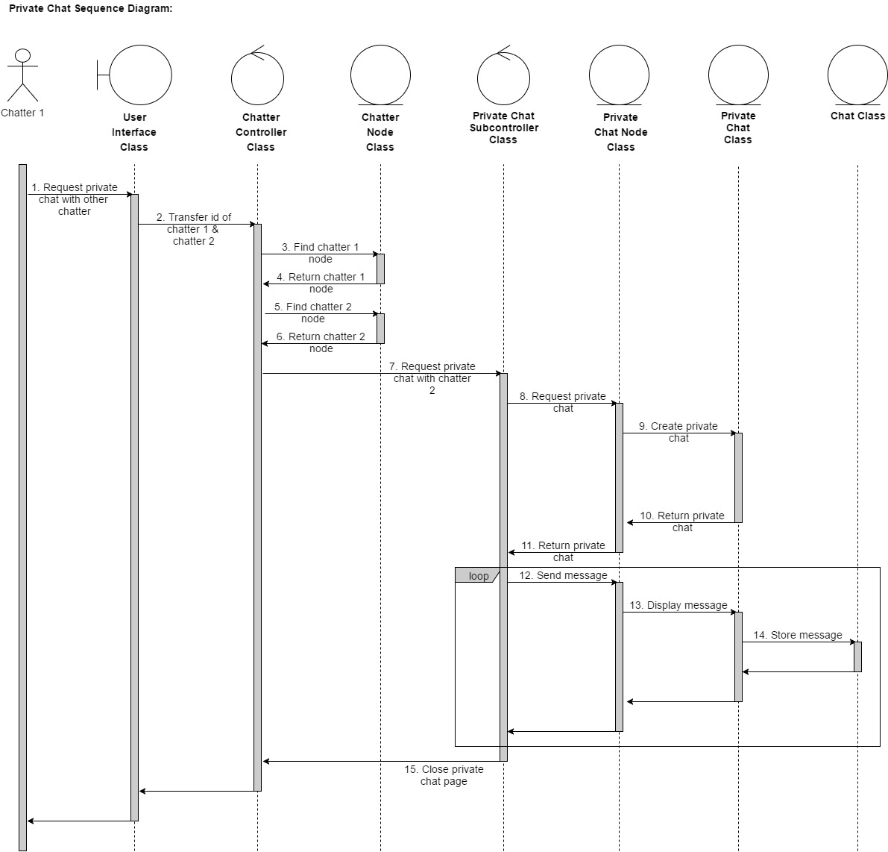

## Message Sent

If text field is not empty, this module will display the message and store it in the Private Chat record.

## Empty Message Sent

If text field is empty when Chatter 1 clicks “Send”, this module will do nothing.

## Access Chat Records

This module will allow users to search their previous conversations in the Private Chat environments they have participated in. This project will pass the test case when Chatter 1 can access all their previous Private Chats. To search their Public Chat records, Chatter 1 can scroll up in the Public Chat environment.

## No Records Exist

If Chatter 1 has not participated in any Private Chats, this module will inform Chatter 1 of that.

## Records Exist

If Chatter 1 has participated in any Private Chats, this module will open their Private Chat environments and display messages from records.

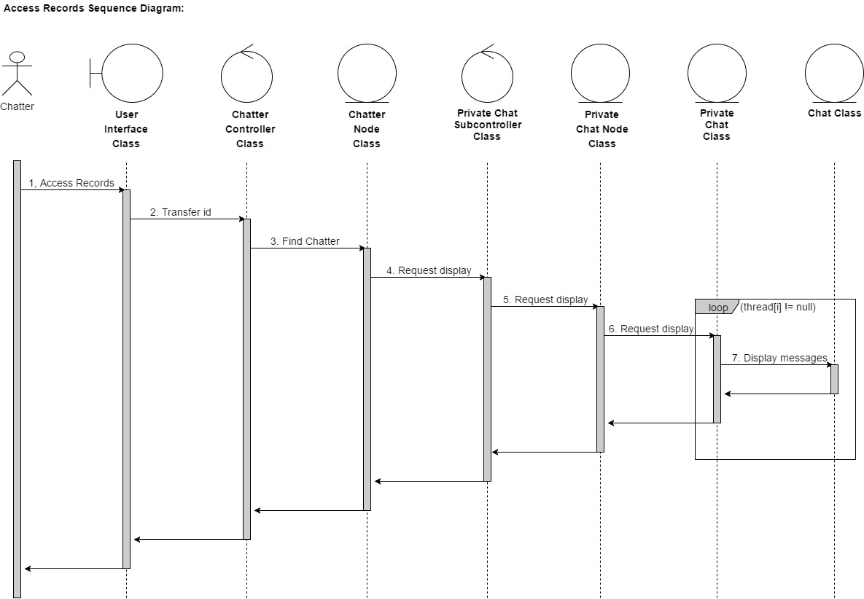

## Log Out

This module will close all the open windows and change Chatter 1’s status as logged out.

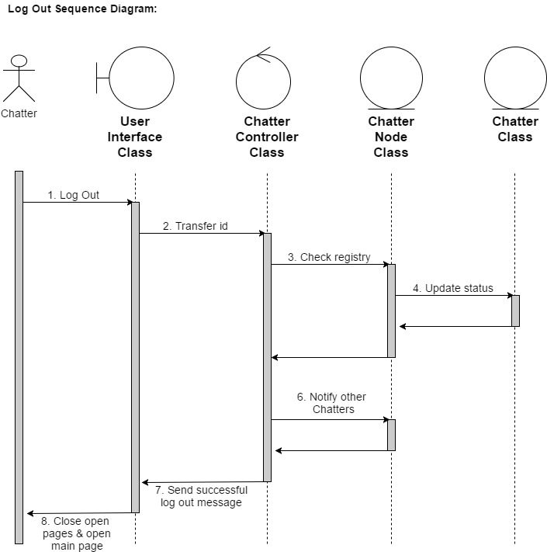

# Integration Testing

This section describes testing to be done during integration. It will contain tests for network communication.

## Register

This module will create an account for a new Chatter 1. It will ask Chatter 1 to enter an ID and enter a password twice for comparison. If both passwords match, this module will connect to the server to search the database of existing Chatters and determine if the ID entered is available. If ID is available, an account will be created and stored in database, Chatter 1 will be logged in, and Chatter 1 will be allowed access to application. Project has passed test case when new Chatter 1 is listed in logged in Chatter list.

### Input Data

Testing for this module will check what happens when incomplete or incorrect data is entered in the ID and Password text fields.

### No ID

If no ID is entered, then Register will inform Chatter 1 that an ID is required to register.

### ID & No Passwords

If ID is entered but no Passwords are entered, Register will inform Chatter 1 that Passwords are required to register.

### ID & Passwords Don’t Match

If ID is entered and Passwords don’t match, Register will inform Chatter 1 that their Passwords don’t match.

### ID & Passwords Match

If ID is entered and Passwords match, Register will connect to the server and search database of Chatters to determine if the ID entered is available.

### ID Already Exists

If the ID entered by Chatter 1 already exists, Register will send a message back to the program that the ID already exists and inform Chatter 1 to choose a different ID.

### ID Is Available

If ID entered is available, testing will be done on the location of new Chatter 1 in the Chatter database.

### ID Is Alphabetically First

Account will be entered in the farthest node on the left of the tree Chatter database.

### ID Is Alphabetically Last

Account will be entered in the farthest node on the right of the tree Chatter database.

### ID Becomes New Root in Chatter Tree

Account will become the new root of the tree Chatter database.

### ID Within Range

Account will be entered within the accepted range away from the boundary cases.

## Log In

This module will ask Chatter 1 to enter in their ID and Password. If input is acceptable, it will search Chatter database to find ID. If ID is found, the module will compare the entered Password with the Password on file else it will alert the Chatter 1 that the ID does not exist. If the Password matches, Chatter 1 will be marked as logged in else it will alert Chatter 1 that the Password does not match the one on file. If ID and Password match, Chatter 1 will be granted access to application. Project has passed test case when new Chatter 1 is listed in logged in Chatter list.

### Input Data

Testing for this module will check what happens when incomplete or incorrect data is entered in the ID and Password text fields.

### No ID

If no ID is entered, then module will inform Chatter 1 that an ID is required to log in.

### ID & No Password

If ID is entered but no Password is entered, the module will inform Chatter 1 that a Password is required to log in.

### ID & Password

If ID and Password are entered, the module will connect to the server and search the database of Chatters to determine if the ID entered exists.

### ID Doesn’t Exist

If ID does not exist, send message back notifying program to alert Chatter 1 that the ID entered does not exist.

### ID Exists

If ID entered by Chatter 1 exists in the database, check to verify that the Password entered matches on file Password.

### ID Exists, Password Doesn’t Match

If the ID entered exists but the Password does not match what is on file, alert Chatter 1 that the Password entered does not match on file Password.

### ID Exists, Password Matches

If the ID entered exists and the Password matches, this module will grant access to application to Chatter 1 and alert other Chatters that Chatter 1 has logged on.

## Chat

There are two chat environments in this application. The Public Chat module allows Chatters to send messages to and receive messages from other logged in Chatters. Public Chat also shows the list of logged in Chatters. Chatters can double click on another Chatter on this list to open a Private Chat with them.

## Public Chat

Testing for this module will include tests for opening Public Chat. Testing for Sub-cases will include tests on sending and storing messages as well as opening a Private Chat with another Chatter. Project will pass test case when Public Chat environment opens.

## Open Public Chat

If Chatter 1 clicks on “Public Chat” button, this module will connect to the server and open the public chat environment.

## Messages

Testing messages will include tests for sending a message of length greater than 0 and sending a message of length equal to 0.

## Message Sent

If text field is not empty when Chatter 1 presses “Send” button, this module will display message on the text area, send the message to the server to display on other Chatters Public Chat screens, and store the message in the Public Chat records.

## Empty Message Sent

If text field is empty when Chatter 1 presses “Send” button, this module will do nothing.

## Open Private Chat

If Chatter 1 double-clicks on another Chatter in the list, this module will open a Private Chat environment for the Chatter 1.

## Private Chat

Testing for this module will include test for sending and storing messages. Project will pass test case when messages are sent and stored in records. When Chatter 1 sends the first message this module will connect to the server, search for Chatter 2 in database, and open a Private Chat environment.

## Message Sent

If text field is not empty when Chatter 1 presses “Send” button, this module will display message on the text area, send the message to the server to display on Chatter 2’s Private Chat screen, and store the message in the Private Chat records.

## Empty Message Sent

If text field is empty, this module will do nothing.

## Access Chat Records

This module will allow users to search their previous conversations in the Private Chat environments they have participated in. This project will pass the test case when Chatter can access all their previous Private Chats. To search their Public Chat records, Chatter can scroll up in the Public Chat environment.

## No Records Exist

If Chatter 1 has not participated in any Private Chats, this module will inform Chatter 1 of that.

## Records Exist

If Chatter 1 has participated in any Private Chats, this module will connect to the server, search for their Private Chat records, open their Private Chat environments, and display previous messages from records.

## Log Out

This module will close all the open windows and change Chatter 1’s status as logged out and inform the other Chatters that Chatter 1 has logged out.